**The Salons Project**

**Determination of Heterogeneity through Network Analysis**

Tim Gruenhagen Tyler Peterson Scott Sirk

Writing and Research Data Visualization Data Cleanup and Prep

Indiana University Indiana University Indiana University

[tgruenha@iu.edu](mailto:tgruenha@iu.edu) [typeter@iu.edu](mailto:typeter@iu.edu) [ssirk@iu.edu](mailto:ssirk@iu.edu)

**Previous Work and Visualization Goal**

The French Enlightenment was a sweeping, two hundred year period of questioning and discovery that shaped the world into what it is today. Beginning with Isaac Newton himself laying the groundwork for classical mechanics and calculus, this tumultuous time saw not only scientific advances, but also the development of core modern day philosophies by notable authors such as Immanuel Kant, John Locke, and Adam Smith. On the surface, this was the age that developed both the steam engine and capitalism, but a deeper dive reveals more than that.

The common thread that ties together the sprawling ideas of a two hundred year period is the emphasis on reasoning and deduction. Prior to the enlightenment, religious orthodoxy dominated and the world was as the church said. Thanks to the early work of Isaac Newton and Descartes, however, questioning the status quo was the new norm. The question is, how did this seemingly generic yet revolutionary idea of “reasoning” permeate from one person to another, starting in France and eventually reaching the Americas?1

In a time of information immobility, discourse was the driver of thought development. In the French enlightenment, there were official academies for developing and discussing ideas pertaining to a certain realm of science or philosophy. Of similar importance, though, were the informal networks of literary “salons” that encouraged productive conversation between a wide range of people.2

An initial analysis of the complex interaction between salons and the academies has been done by Dr. Melanie Conroy3. In her work, she performed extensive network analysis of individuals attending both types of formal and informal social groups. She found that the salons themselves were likely not the gates allowing access to the academy, rather, they were derived from the academies themselves. Based on this, she concludes that both the academies and salons were therefore products of the characteristics of the people that attended them.

The goal of our visualization is to determine the roles of these characteristics in forming the social groups that in turn produced the revolutionary Enlightenment ideas. Were ideas such as capitalism and separation of church and state derived from a diverse body of thought or from the echo chamber of the elites? Did women have an equal say in these groups, or were they underrepresented in certain areas of discussion? How did someone’s nationality or economic status help or hurt them in this time period?

To answer these questions, we aim to look at the French Salon data not as a collection of individuals attending different academies and salons, but as discrete groups of people going from one to another. By grouping people by their professional, political, religious, etc. similarities, we aim to draw conclusions about the formations of the Enlightenment ideas. Knowing the context behind how an idea is formed is just as important as the idea itself, and we hope to uncover that with our analysis. Initial sketches of how this analysis will be done can be seen below:



**Figure 1:** Potential network analysis would involve creating a network of people

and coloring by characteristic. In this figure, there are three distinct clusters,

and each cluster appears to have a unique dominant characteristic.



**Figure 2:** Alternatively, salons and academies could be grouped by the number of people

of a certain characteristic and shown as a much simpler network. Here there are

four nodes representing four salons/academies, and it is apparent that one of

them is overrepresented in the yellow characteristic.

**Data Overview**

The provided Salons dataset is information rich with descriptions of over 700 different individuals’ occupations, salon attendance, ego networks, gender, nationality, and more available for analysis. Each individual shown here is complex, with potentially multiple connections to different salons, academies, and so on. For example, there are a total of 782 people that were a part of 56 different ego networks. Each of these people were on average contributing to 1.73 ego networks on their own, with some people contributing to up to 13 different networks. Similarly, each person attended on average 1.49 salons, with someone attending 10 separate salons. The entire dataset is itself 73% male and 84% French.

Seen below are the 10 most attended ego networks and salons, where Encyclopedistes is the most prolific ego network and Deffand is the most commonly attended salon:



Looking at these from an individual level, one can see that although the majority of people only attend one or two salons or ego networks, there are a select few that attend many. This can be seen in the histograms below:



Using the descriptive information below helps guide us towards how we will visualize the salon networks in order to gain insights as to how certain characteristics may have influenced certain lines of thinking in the enlightenment period.

**Forming a Network**

Network analysis of these data requires parsing the data down in multiple ways. Since a network is a set of nodes connected by edges, our data needed to be converted to just that. In order to do this, the data had to be converted to an edge list detailing the connections between certain subsects of the data. Finally the edge list was consolidated down based on the number of occurrences of each connection. An example of this framework can be seen below for three entries in the ego networks column:

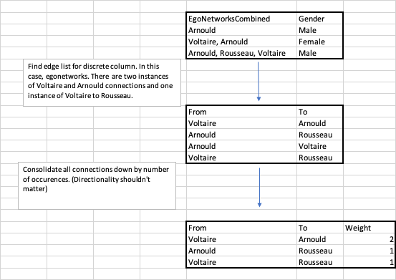

Additionally, it was important to describe each node in the network by an attribute. This simply required grouping each node by the attribute to find how often that attribute occurred. Since each person attended multiple academies, salons, and ego networks, no node can be described to have a discrete characteristic of male or female, French or English, etc. Therefore, we have plotted said characteristics based on the majority of attendance to start.

An initial network graph of the Ego Networks with each node sized by attendance and colored by majority male or female can be seen below. Additionally, the thickness of the edges connecting the nodes describes how often those connections occurred:

PASTE NETWORK GRAPH HERE

**Network Insights**

For this initial ego network graph there are a few key insights. First off, the ego networks are most often majority male, with a few majority female ego networks that appear sparsely attended and not well connected to the others. This is both not surprising and unfortunate. It is not surprising given the time period, but unfortunate how such important ego networks appear to have little contribution from 50% of the population. Additionally, there are a certain few clusters of ego networks that appear to have others stem from them, such as Voltaire and D’Alambert. These were likely the leading thinkers of the time and the others probably gained much influence from them.

In the following analyses, we aim to develop similar networks for the salons, academies, and so on, and to characterize them on columns such as occupation and nationality. We will likely tweak the network visualization, messing around with centrality and different ways to layout the data. The ultimate goal of these analyses is to gain a better insight on the underlying characteristics of the people who so strongly shaped the Enlightenment movement, and the proper network graphs should get us there.

**References**

1. Weber, E. *Movements, Currents, Trends: Aspects of European Thought in the Nineteenth and Twentieth Centuries.* 1992.
2. Dorinda, O. *Panorama of the Enlightenment.* 2006. Getty Publications, p 29. ISBN 978-0892368617
3. Conroy, M. *Networks of the Enlightenment*. 2019. **The Workshop**, Number 6.